Functional Requirements:

**Input:**

Once the user creates a case on the workflow, all the uploaded documents are saved to a SharePoint location. This location reference will be sent to the deployed model endpoint as part of the inference request. Refer solution structure below:

Expected document formats: PDF, MS Word, TIFF (for extraction), Email (Outlook)

Documents in Scope: Types of Documents from WBG in scope for the MVP

|  |  |  |  |  |  |  |  |  |  |  |  |
| --- | --- | --- | --- | --- | --- | --- | --- | --- | --- | --- | --- |
| Finance Document (for WCF) | | | Finance Document (for Rupee Term Loan) | | | Security/ Contractual Comfort (as applicable) | | | Corporate Authorisations (as applicable) | | |
| Document  Name | Doc versions | #of clauses | Document Name | Document versions | #of clauses | Document Name | Doc  Version | #of clauses | Document Name | Document versions | #of clauses |
| Working Capital Facility Agreement (High Rated) | 1 | 120 | Corporate Loan Facility Agreement (High Rated) | 1 | 120 | Deed of Hypothecation (2 types, 4 parts) | 4 | 50 | Board Resolution - Borrower | 1 | Approx 10 |
| Working Capital Facility Agreement (Low Rated) | 1 | 120 | Corporate Loan Facility Agreement (Low Rated) | 1 | 120 | Pledge Agreement | 1 | 50 | Board Resolution – Third Party (Guarantee/ Third Party Security) | 1 | Approx 10 |
| Note of Amendment | 1 | 10 |  |  |  | Mortgage Declaration - Borrower | 1 | 15 | Shareholders’ Resolution u/s 180(1)(a) – Borrower | 1 | 7 |
|  |  |  |  |  |  | Memorandum of Entry - Borrower | 1 | 5 | Shareholders’ Resolution u/s 180(1)(a) – Third Party Security Provider | 1 | 7 |
|  |  |  |  |  |  | Deed of Guarantee (Corporate/ Personal) | 2 | 35 | Shareholders’ Resolution u/s 180(1)(c) | 1 | 5 |
|  |  |  |  |  |  | Deed of Mortgage (Simple Mortgage to be registered) Borrower, third party | 2 | 52 | Shareholders’ Resolution u/s 185 | 1 | 10 |
|  |  |  |  |  |  | Deed of Reconveyance | 1 | 15 | Shareholders’ Resolution u/s 186 | 1 | 10 |
|  |  |  |  |  |  | Mortgage Declaration - third party | 1 | 15 |  |  |  |
|  |  |  |  |  |  | Memorandum of Entry - third-party) | 1 | 5 |  |  |  |

**Expected output:**

|  |  |  |
| --- | --- | --- |
| Categories | Features | Expected Output from AI |
| E-Discovery (AI driven analysis of documents) | Classify the new documents (39 categories of documents) | Classification for each document. |
|  | Extraction of meta-data | Meta-data defined for each doc type. (Refer Document Details Table) |
|  | Extraction of focus-areas, clauses. This would also include Table-Extraction. | Clauses as defined for each doc type with the clause name, text, and area co-ordinates. (Refer Document Details Table) |
| Deviation Status Detection (for only standard documents) | Identify deviation in clauses for all documents (With standard template). | All clauses with deviation for each document. Clause name, Clause text, Standard Clause text and Clause co-ordinates in the doc would be expected. |
| AI Recommendation Engine & Next best action (Supervisor / Approver / Business) | 1. Find similar documents or positions taken based on type of client, document (std and non -std) clause: 2. Stipulated Clause under Sanctioned Terms/ Credit Arrangement Letter; 3. Similar Clause with the Same Client/ Counter-party for earlier transactions; 4. Similar Clause with Group Companies of Same Client/ Counter-party; 5. Similar Clause with Other Companies. (Based on rating) | Similar document name, meta-data (Name of the client and Internal Rating, Approving Authority (with zone), Comment from previous deviation approval for all four criteria wherever applicable.  Note: Mapping needed for companies -> group companies (Legal team to provide).  User to add Group and rating details during case creation. (TBC) |

All outputs are expected in JSON format via REST calls. Refer integration view below

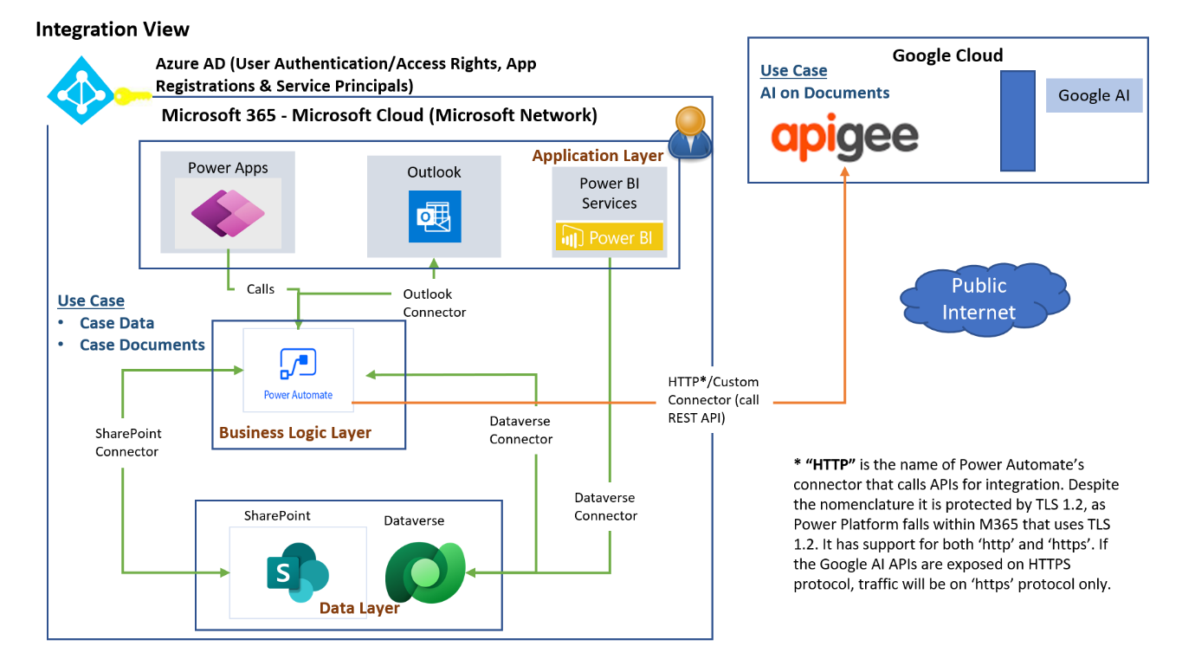

Document Details Table:

|  |  |  |
| --- | --- | --- |
| Doc Type | Meta-Data | Focus-Areas  (Excel sheets have a detailed description of all the clauses to be extracted from the document) |
| Rupee Term Loan Facility Agreement for High Rated Borrowers | 1. Name of borrower 2. Registered office and corporate office 3. Lending branch 4. Amount of facility 5. Tenor of facility 6. No. of tranches 7. Repayment |  |
| Deed Of Hypothecation- Third Party | 1. Name of Hypothecator 2. Name of Borrower 3. Details of secured assets |  |

Note: Currently details of Meta-Data and Focus-Areas is available for 2 out of 39 categories of documents. Details for rest would be added post initial discussion.